Tour comment’s 2014-16.
November-23 to26 , 2014.
We very much enjoyed four days of birding in the Nainital area sat-tal, Snow-view chaffi, Ramgarh etc. With our knowledgable, patient and kind guide Mr. Sunil Kumar.
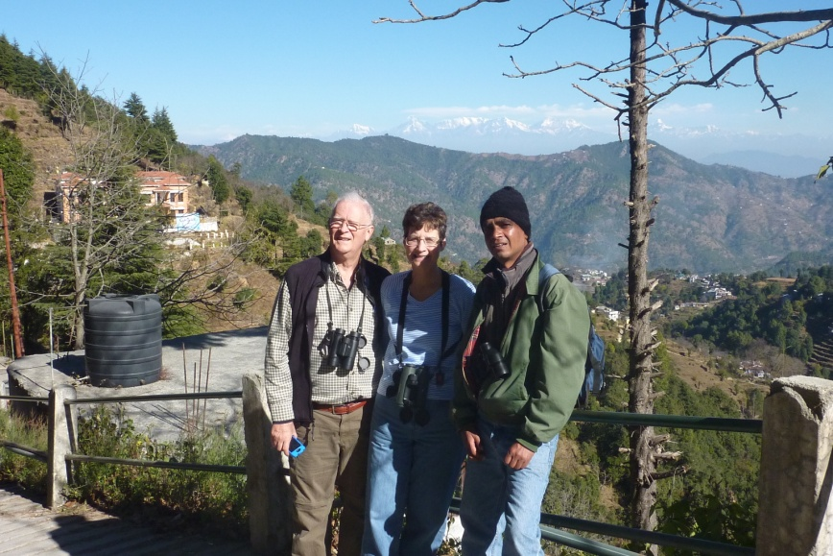
He planned a very organised trip, and all occured in timely manner .He patently made sure we had an opportunity to see the bird and watch their behaviour as time allowed, and we took time to photograph as well.
Sunil was gracious to help with transport arrangement for our onward destinations in India as well with train car and driver.
We highly recommend Sunil as a birding Guide, for his Knowledge of the birds, their calls, habitats and love to share with others.
We have been blessed to have Sunil as a Guide and to call him a friend.
Bill & Gita Gerling (U.S.A)
Email-agl_gerling1@hotmail.com

12 February 2015.
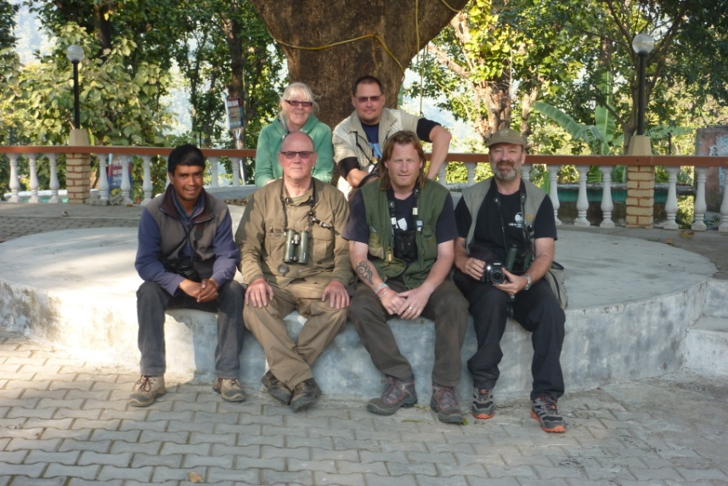
We have enjoyed 9 days birding with Sunil, covering Corbett, Pangot, Sat-tal area. We have seen all our target birds for this area including Ibisbill, Nepal Wren Babbler (including finding a new site near Bhimtal) Himalayan Ruby throat, Cheer Pheasant (3 first day 6 2nd day)Long-billed, Tickell’s, Plain-backed, Orange-headed Thrushes, White-collared and Grey-winged Blackbird .Wallcreeper, Black Eagle, Lammergeier, Hill Partridge, Upland Pipit, Rufous Alpine and Altai Accentors and Tawny Fish Owl.
Sunil is Knowledgable and keen about birds, he is excellent at picking up moment and can hear a leaf rustle at 30 paces .An all round great guy and good company.
We would all recommend Sunil to guide any birder who visits the Kumaon area.
Paul Thomason-Tropical,
Nell Hunt-Err Neill,
Peter Allan-Playful,
Mike Stocker-Pretty boy,
June Watt.
MARASHSIDES FINEST (U.K)
Email- caspersdoghouse@aol.com
Neill.hunt@hotmail.co.uk
Mikestocker75@hotmail.com
Pallen75@hotmail.co.uk

Date 19 April to 22 April, 2015
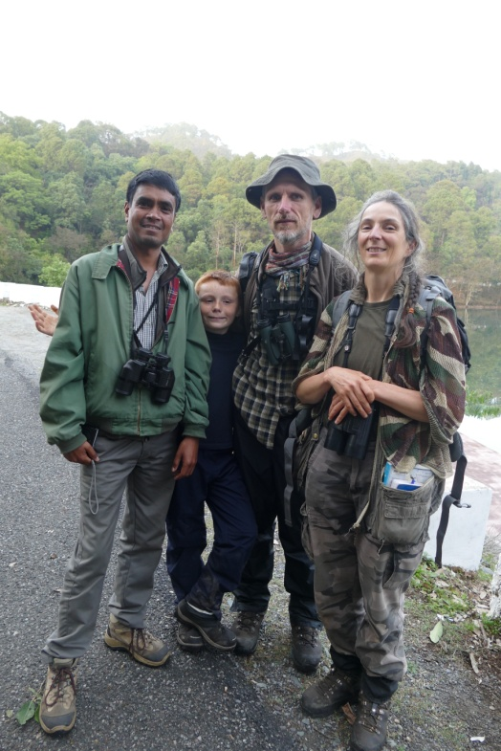
We are a pair of French mad birdwatchers used to travel by ourselves around the world to watch birds in Asia, Africa, and we few turn to guides. In our North-West India journey since mid-april 2015, we came to Pangot and Nainital area to watch thrushes, pheasants, and some local specialities as Rufous-chinned Laughingthrush. We had few time to spend, not at usual time, in this place known in winter for thrushes, so we turned to Sunil Kumar, due to great testimonials on Birding Pals, and we were not disappointed. Sunil knows very well his area and birds. He learns quickly what you expect. He knows what photography requires. On the ground he’s quiet and efficient. We really enjoyed our time with him. He made good briefings of our driver, and optimized for bird-watching driving in all montane forest roads. We’ll not forget him, as we discovered with him a Pied Thrush in a place unexpected for this wonderful bird. And Sunil is very friendly, and our young boy, 8y-old, who travelled with us but not specially interested in birds, nor English speaking, keep a pleasant recollection of Sunil as a wonderful friend. Our only disappointment is to have visited Corbett without him, due to a disagreement with the agency and the hotel, and we are sorry for. We not often recommend a guide, but we recommend Sunil !
Marianne & Thierry Quelennec
France.
Email-croac29@wanadoo.fr

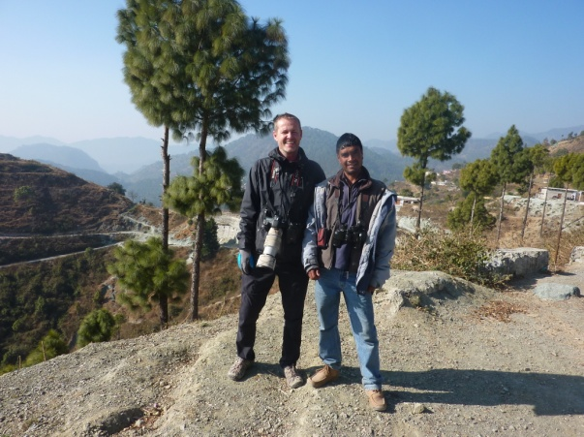
1-Thank you Sunil for a really nice and good trip! Sunil is a very good guide.He works hard to find new birds and has a good eye .You are also a good companion .I trust Sunil 100%
Hope to see you again.
Bjorn Kjellemyr (Norway.)
Email-bjokjell@yahoo.no
Date-04 Jan-13 Jan-2016.

2-My experience of Sunil i :
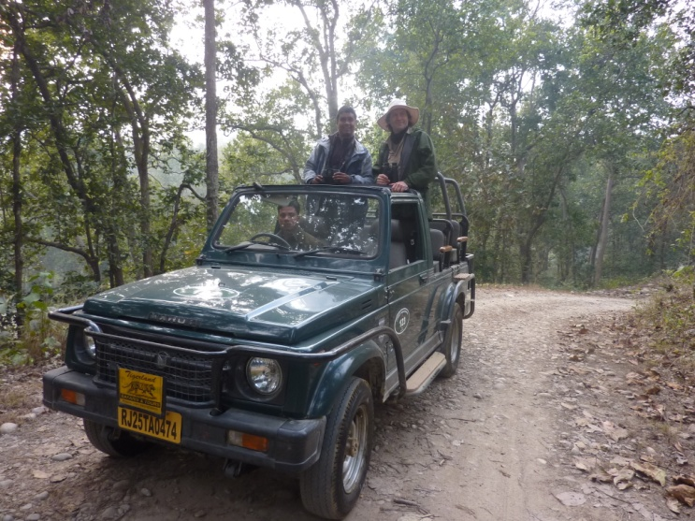
He responsed prompthy in my communications by email. He was helpful and gave excellent advice on planning my birding trip. Upon meeting Sunil. I found him to be a most pleasant, honest, lovely carving person who showed real concern for nature and the environment. I completely enjoyed my tour with Sunil. He is an easy person to be with and I liked his personality and his humour. There is no doubt that Sunil has a vast amount of bird watching Knowledge and experience and a very sharp eye’s for spotting and recognising the birds which constantly amazed me. Sunil is good at recognising bird calls and often is announce of the presents of a bird before it is seen.
In my many years as a bird watcher I have met many bird guides and people who claim to be bird guide.I know a genuine bird watcher and bird lover and Sunil is definitely one, and one of the best,if not the best I have met.
I do not hesitate recommending .Sunil as a bird guide for anyone who needs one. If I return to North India,my first choice for a guide would be Sunil. In total we saw over 180 birds at a time when condition were not the best which is out of the control of the bird guide.
I have enjoyed my time with you Sunil and wish you were guiding me on the rest of my trip.You are a very good man.I hope we meet again soon.sunil my friend.Best wishes.
Gary Buckett.North Wales (U.K)
Email-sailaway8@hotmail.com
Date-28 Jan.-5 Feb.-2016.

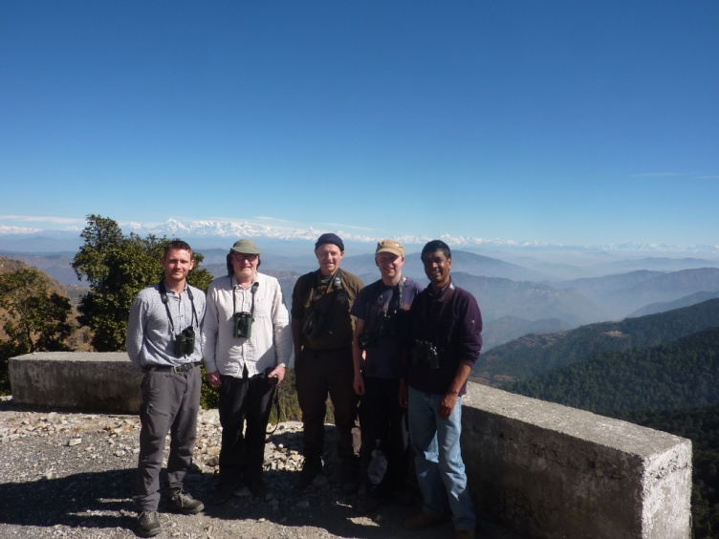
3-Sunil is a great guy and very friendly. He is knowledgeable about birds and many other things, I enjoyed talking to him about politics.
I highly recommend Sunil as a guide.
Thanks for a great trip.
From all. P. Middletion, S. Wignell, Carl Dixon and N. Addey. (Yorkshire Birders.)
Email-nickaddey@dsl.pipex.com
Date-12 Feb.-19 Feb. 2016.

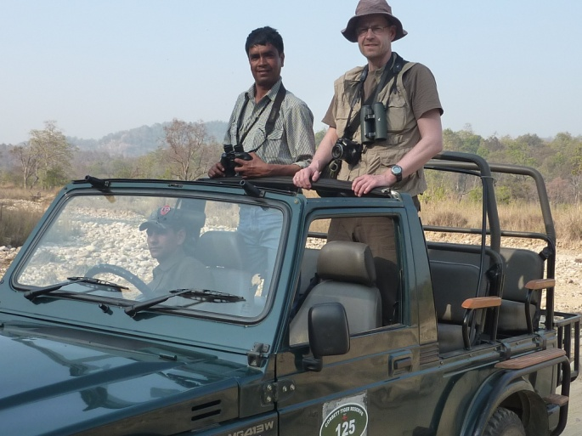
4-I was birding with Sunil in Sattal,Pangot and Corbett.Great time with lots of birds.Sunil is an excellent bird guide and a good refreshing company.He worked hard to find the Koklass Pheasant and we climbed down the mountain (and up again...)to find the Cheer Pheasant. Both target birds found! Scaly-breasted and Nepal Wren Babbler,Sunil knows the stake-out. I can recommend him to every hardcore birders.
Thanks very much.I enjoyed the trip.
Mr.Jorg Hanoldt.Hambarg (Germany.)
Email-toucanet@online.de
Date-26 Feb.-5March.2016.

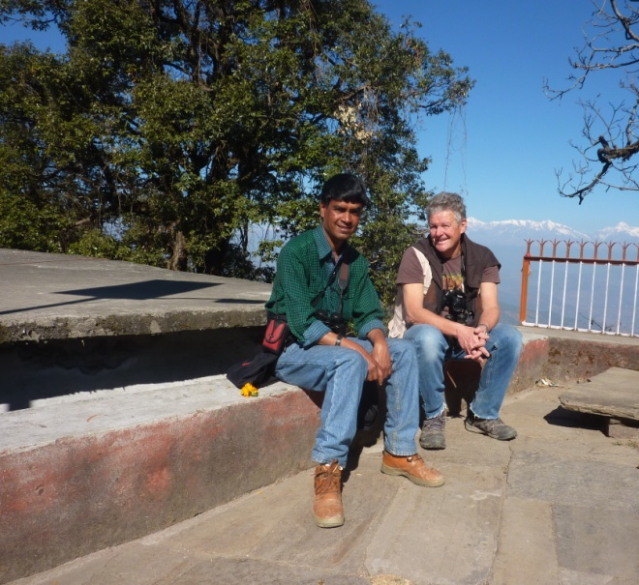
A perfectly organised tour in Uttarakhand nice places to stay,superb landscapes excellent walks and most important plenty of birds and a competent ,very organised and very nice guide is the person of Sunil Kumar.
What else might I have desired for my third holidays in North India ?
Thank you Sunil, really a very big thank you to you for everything.
Mr. Frederic raes.
Email-z60m@outlook.cm
Belgium.
23rd November to 7th December -2016.

